NATIONAL OCEANIC AND ATMOSPHERIC ADMINISTRATION
US DEPARTMENT OF COMMERCE
A Bibliometric Analysis of Articles by NOAA-Affiliated and Funded Authors Published During Fiscal Year 2021

Prepared by Sarah Davis,
Jan Thomas and Hope Shinn
NOAA Central & Regional Libraries
March 2022
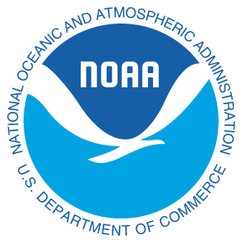

ABOUT THIS REPORT
This report presents a summary-level bibliometric analysis of peer-reviewed articles produced by NOAA-affiliated and funded authors during the U.S. Government fiscal year 2021 (October 1, 2020 to September 30, 2021). In this report, we attempt to provide a high-level overview of the number of articles produced per quarter, line office, and research unit; the intramural and extramural collaborations that produced these articles; and trends in NOAA publication habits.
The data presented in this report were derived from the Web of Science, Science Citation Index Expanded and Social Science Index (WoS) database and are accurate as of 17 February, 2022. Articles were identified by searching for NOAA, NOAA line offices, or NOAA research units in the authors’ stated affiliations and funding text. Search results were manually reviewed and verified for accuracy and, when applicable, assigned to line office and research labs based on the NOAA authors, or authors’, listing in the NOAA staff directory. Our use of WoS to identify publications means that peer-reviewed publications by NOAA authors and NOAA-funded authors in publication venues not available in WoS – primarily book chapters, technical reports, data sets, and articles in some journals – are not included in this analysis.
The finding presented here are those of the authors and do not necessarily reflect any opinion or position of NOAA, the Department of Commerce, or the U.S. Government.
Questions about this report should be directed to Sarah.Davis@noaa.gov.

CONTENTS
ABOUT THIS REPORT 2
NOAA ARTICLE PRODUCTION 3
ARTICLE PRODUCTION AND COLLABORATION BY NOAA AUTHORS 7
Collaboration 9
Publication Trends 13

NOAA ARTICLE PRODUCTION
The following figures analyze the number of publications published by NOAA employees, contractors, and grant funded authors in FY2021. In this section NOAA-authored and NOAA-funded articles are collectively referred to as NOAA articles. Figures 2 and 3 show the top results in journal title and subject category for all NOAA articles and also show a breakdown of articles by NOAA authors and NOAA-funded authors to illustrate differences in intramural and extramural research publications. Figures 3 and 4 address the breadth of NOAA’s research through quantitative analysis (figure 3) which illustrates the variety of subject areas covered and network analysis (figure 4) which illustrates the ways in which these research areas are perhaps connected.

FIGURE 1: Non-cumulative number of peer-reviewed articles by NOAA authors per quarter. There were 2,252 NOAA-authored and 1,908 NOAA-funded articles published during FY2021 for a total of 4,160 articles.

FIGURE 2: Number of peer-reviewed NOAA-authored and -funded articles per journal. NOAA articles appeared in 637 distinct journals in FY2021 however, only the top 10 journals by publication count are shown.

FIGURE 3: Number of NOAA-authored peer-reviewed articles per subject category. Subject categories are defined, and assigned to articles, by Web of Science based on the journal in which each article was published. These categories overlap, so a single article can be assigned to multiple subject categories. Only the top 15 subject categories by publication counts are shown.
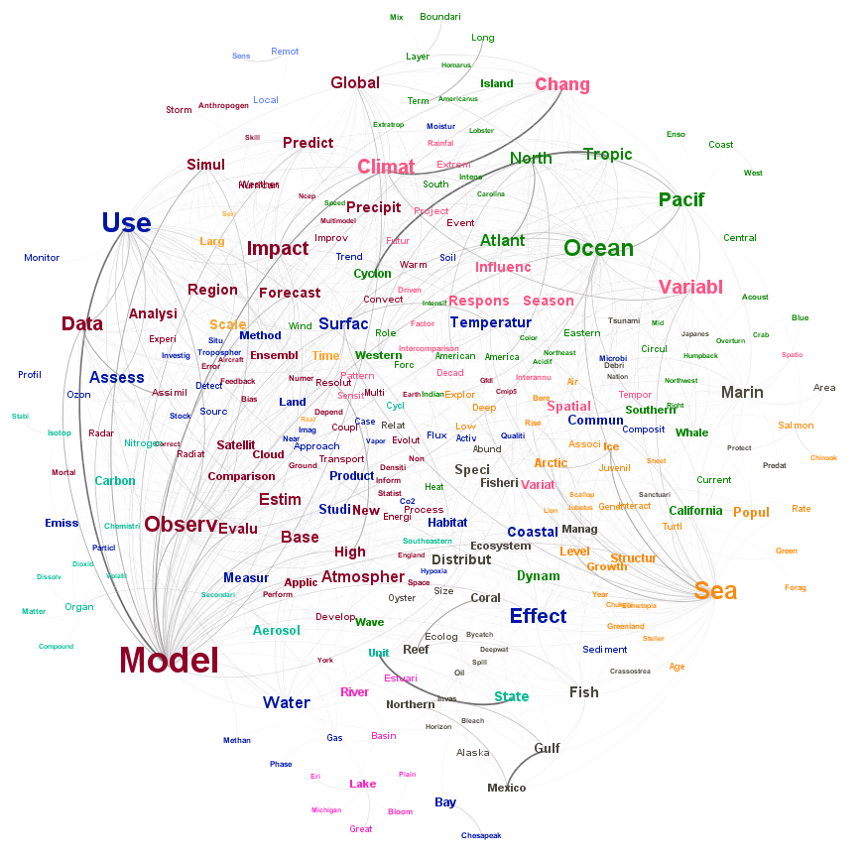
FIGURE 4: Word co-occurrence network of the 285 most frequently co-occurring words in the titles of NOAA articles published in FY2021. Words are sized based on the number of titles in which the word appears and colored to illustrate groups of words that tend to be used together in publication titles. Words are connected if they both appear in the same article title; larger and darker connections indicate higher numbers of title co-occurrences (co-occurrence values range from 8 to 73). Words and word co-occurrences that appear in fewer than 8 article titles were removed to increase visual clarity and to focus on the most important words and word pairs.

ARTICLE PRODUCTION AND COLLABORATION BY NOAA AUTHORS
The following figures analyze only those publications authored by NOAA employees and contractors as a greater level of detail is available for these articles. These figures illustrate article production by line office and research unit (figures 5, 6a, and 6b), collaboration between NOAA authors and outside researchers (table 1, figures 7-10), and trends in article production from FY2012 to present (figures 11 and 12).

FIGURE 5: Non-cumulative number of peer-reviewed articles by NOAA-affiliated authors per quarter per line office. A single article with authors from more than one line office is counted as one article for each line office.
FIGURE 6a: Number of peer-reviewed articles per Line Office as a percentage of all NOAA-authored publications. A single article with authors from more than one line office is counted as one article for each line office.

FIGURE 6b: Number of peer-reviewed articles per research unit as a percentage of all NOAA-authored articles. A single article with authors from more than one unit is counted as one article for each.

Collaboration
NOAA authors collaborate in their research with other authors both within NOAA and externally. These figures seek to illustrate the rates at which NOAA authors collaborate with other researchers as well as which institutions and nations those researchers are affiliated with.
Type of Collaboration | Rate
Intramural collaboration at the line office level | 6.25 %
Intramural collaboration at the research unit level | 11.93 %
Extramural collaboration at the institutional level | 94.83 %
Extramural collaboration at the international level | 39.67 %
TABLE 1: Collaboration rates at various levels of aggregation for NOAA-authored publications in FY2021. Each percentage gives the percentage of all NOAA-authored publications that feature at least one co-authorship pair at each level of aggregation.

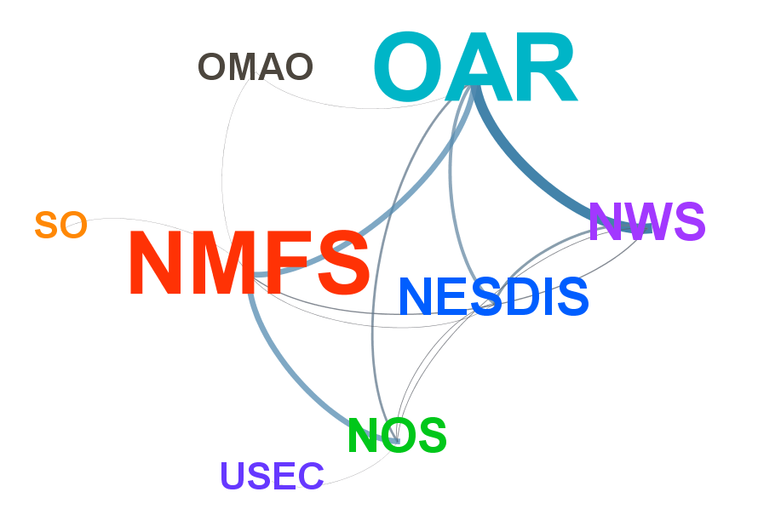
FIGURE 7: Collaboration network of NOAA line offices based on co-authored publications in FY2021. Line offices are sized based on the number of publications produced during FY2021. Line offices are connected if authors from the connected offices co-authored one or more publications during FY2021, with larger and darker connections indicating higher numbers of co-authored publications (connection values range from 1 to 43).
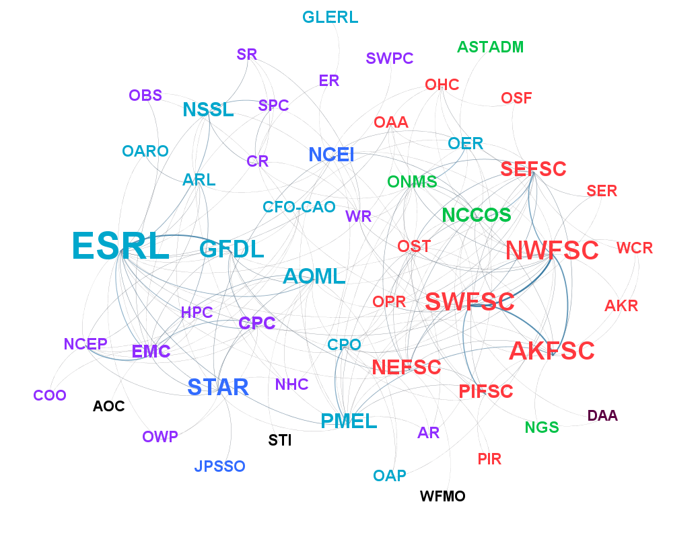
FIGURE 8: Collaboration network of NOAA research units based on co-authored articles in FY2021. Units are sized based on the number of articles produced during FY2021 and colored by line office. Units are connected if authors from the connected units co-authored one or more publications during FY2021, with larger and darker connections indicating higher numbers of co-authored articles (connection values range from 1 to 13). For visual clarity, only units that co-authored at least two articles with another unit are shown.

FIGURE 9: Top 15 extramural collaborators as measured by the number of peer-reviewed articles co-authored by authors from NOAA and each institution.
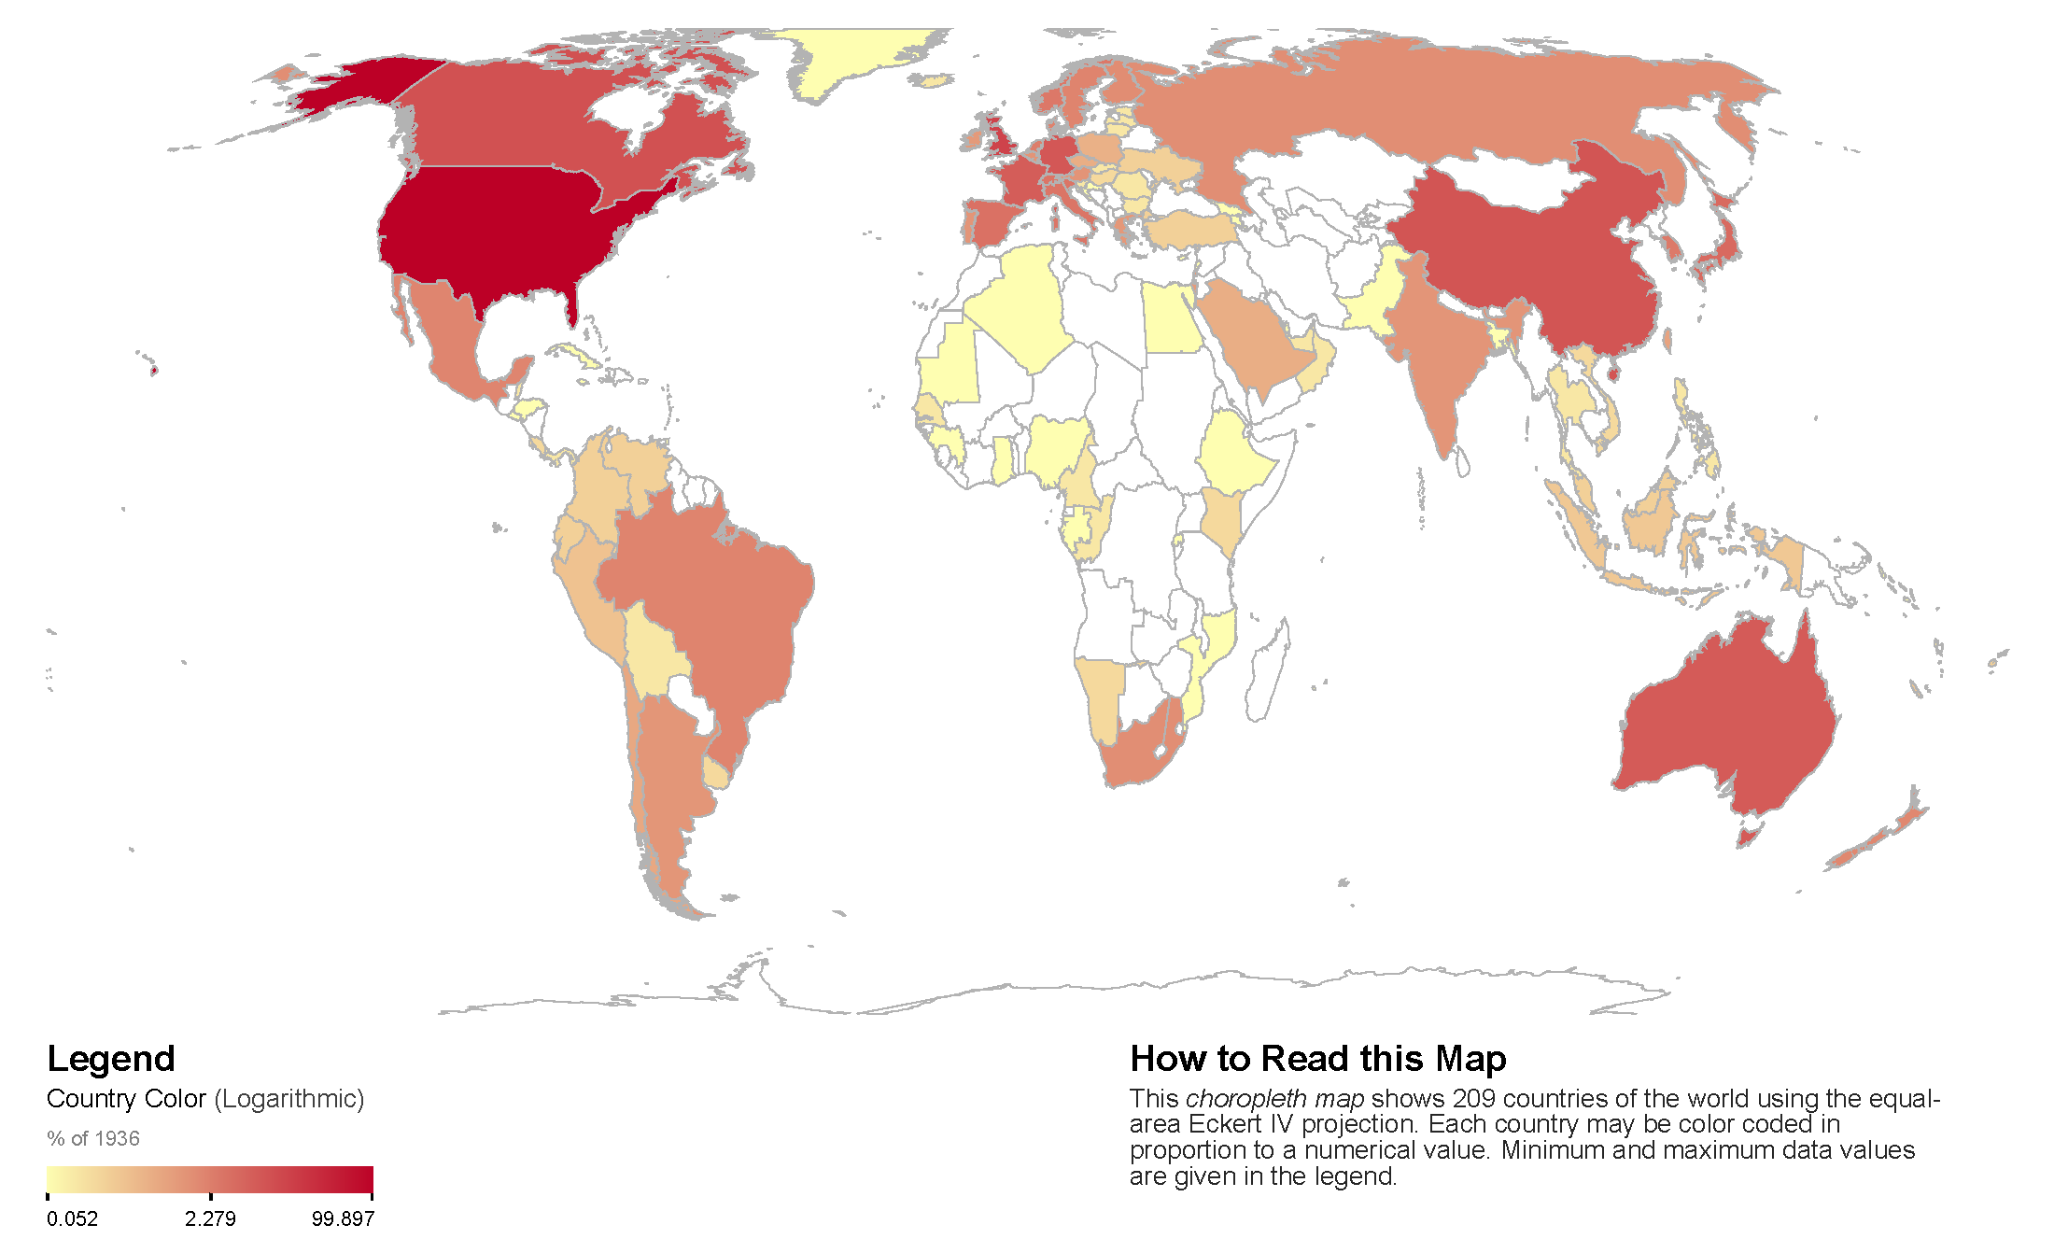
FIGURE 10: Geographic map showing NOAA’s international collaboration as measured by the number of articles co-authored by authors with institutional affiliations in countries outside the US.

Publication Trends

FIGURE 11: Non-cumulative number of articles by NOAA-affiliated authors per quarter. There were 1,816 articles published in FY2012, 1,913 in FY2013, 1,989 in FY2014, 2,028 in FY2015, 2,066 in FY2016, 2,096 in FY2017, and 1,936 in FY2018.

FIGURE 12: Non-cumulative number of peer-reviewed articles by NOAA-affiliated authors per year per line office. A single publication with authors from more than one line office is counted as one publication for each line office.

